**Комп‘ютерний практикум №3**

**Тема:** Програмування розгалужених алгоритмів.

**Завдання :** Написати програму – календар, яка за введеною датою (виключно дня, місяця, року) виводить день тижня прописом.

***Текст програми:***

#include <stdio.h>

#include <stdlib.h>

#include <conio.h>

int year, month, lyear, day, n, date, j;

char exitchar, x;

enter_day()

{

do

{ x=0;

printf ("\nEnter day from 1 to 31\n\n");

scanf ("%d%c", &day, &x);

if( (x!='\n')||(day<1)||(day>31) )

{

printf ("\nEnter only numbers from 1 to 31\n\n");

fflush(stdin);

j=0;

}

else (j=1);

}

while (j!=1);

}

enter_month()

{

do

{ x=0;

printf ("\nEnter month\n\n");

scanf ("%d%c", &month, &x);

if ((x!='\n')||(month<1)||(month>12))

{

printf ("\nEnter numbers only from 1 to 12\n\n");

fflush(stdin);

j=0;

}

else (j=1);

}

while (j==0);

}

enter_year()

{

do

{ x=0;

printf ("\nEnter year from 1 to 9999\n\n");

scanf ("%d%c", &year, &x);

if(x!='\n')

{

printf ("\nEnter only numbers from 1 to 9999\n\n");

fflush(stdin);

j=0;

}

else (j=1);

}

while (j==0);

}

calculation()

{

switch (month)

{

case 1:

printf ("\nYou wrote a JANUARY\n");

break;

case 2:

printf ("\nYou wrote a FEBRUARY\n");

break;

case 3:

printf ("\nYou wrote a MARCH\n");

break;

case 4:

printf ("\nYou wrote a APRIL\n");

break;

case 5:

printf ("\nYou wrote a MAY\n");

break;

case 6:

printf ("\nYou wrote a JUNE\n");

break;

case 7:

printf ("\nYou wrote a JULY\n");

break;

case 8:

printf ("\nYou wrote a AUGUST\n");

break;

case 9:

printf ("\nYou wrote a SEPTEMBER\n");

break;

case 10:

printf ("\nYou wrote a OCTOBER\n");

break;

case 11:

printf ("\nYou wrote a NOVEMBER\n");

break;

case 12:

printf ("\nYou wrote a DECEMBER\n");

break;

}

if(((year%100!=0)&&(year%4==0))||((year%100==0)&&(year%400==0)))

{lyear=1; // vsokosnii god

printf("\nYou wrote a leap-year\n");}

else{lyear=0; // nevisokosnii god

printf("\nYou wrote a not leap-year\n");}

if ( ((month==4)||(month==6)||(month==9)||(month==11))&&(day==31))

{

printf("\nThis day does not exist (APRIL, JUNE, SEPTEMBER, NOVEMBER have only 30 days)\n");

return 0;

}

if ((month==2)&&(lyear==0)&&(day>=29))

{

printf ("\nThis day does not exist (in not-leap year FEBRUARY have only 28 days)\n");

return 0;

}

if ((month==2)&&(lyear==1)&&(day>29))

{

printf ("\nThis day does not exist (in leap year FEBRUARY have only 29 days)\n");

return 0;

}

if ( month > 2 ) {n=0;}

else if ((month <= 2)&&(lyear == 1)) {n=1;}

else if ((month <= 2)&&(lyear == 0)) {n=2;}

//printf("\nn=%d\n", n);

date = ((long) (365.25*year) + (long) (30.56*month) + day + n)%7;

//printf("\ndate=%d\n", date);

switch(date)

{

case 0:printf("\nMonday.\n");break;

case 1:printf("\nTuesday.\n");break;

case 2:printf("\nWednesday.\n");break;

case 3:printf("\nThursday.\n");break;

case 4:printf("\nFriday.\n");break;

case 5:printf("\nSaturday.\n");break;

case 6:printf("\nSunday.\n");break;

}

}

int main()

{

do

{

system("cls");

printf ("\nWrite down day-month-year to know the weekday\n");

enter_day();

enter_month();

enter_year();

calculation();

printf ("\nEnter y + ENTER to continue\n");

printf ("\nEnter n + ENTER twice to continue\n\n");

exitchar = getchar();

}

while ( (exitchar == 'y')||(exitchar == 'Y') );

}

***Схема до програми:***



***Введені та одержані результати:***

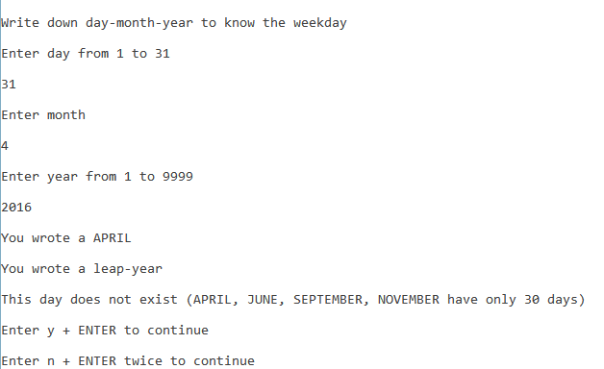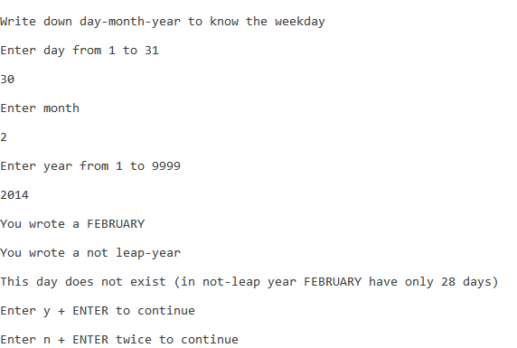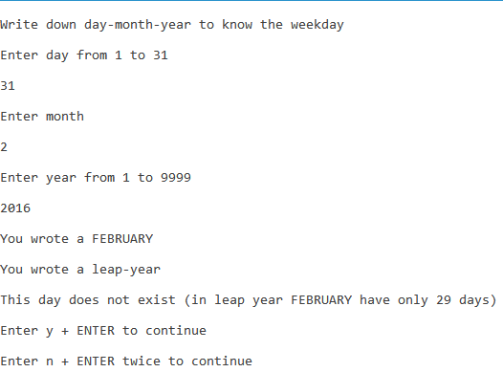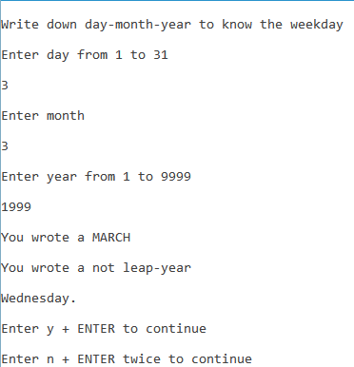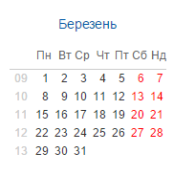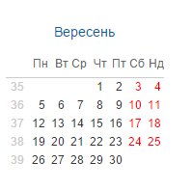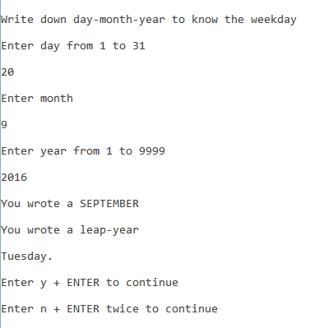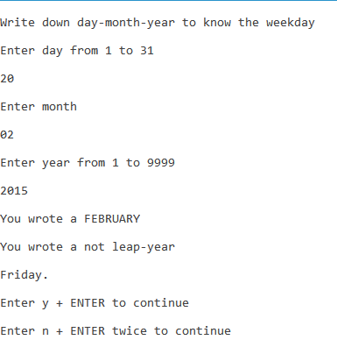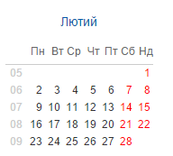

***Теоретичні розрахунки:***

$date=\frac{\left[365.25*1999\right]+[30.56*3]+3+1}{7}=$ 2

$date=\frac{\left[365.25*2016\right]+[30.56*9]+20+0}{7}=$ 1

$date=\frac{\left[365.25*2015\right]+[30.56*2]+20+2}{7}=$ 4

***Висновки***: Програма вирішує поставлене завдання. Теоретичні розрахунки відповідають отриманим. Програма працює корректно.